**Assignment 10.1**

1. **Write a program to implement word count using Pig.**

**Share the screenshots of the commands used with its associated output**

**Sample input file:**

(A simple text file is created with sentences)

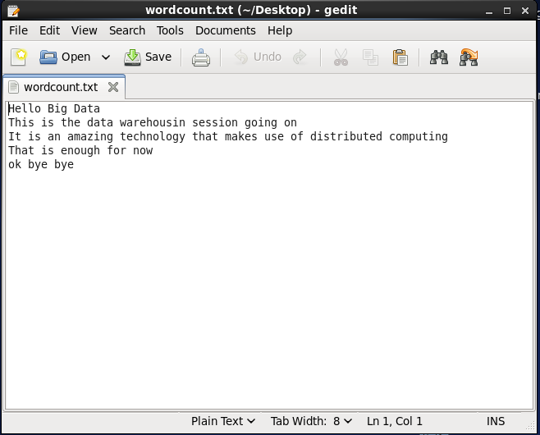

**Load the data from Local:**

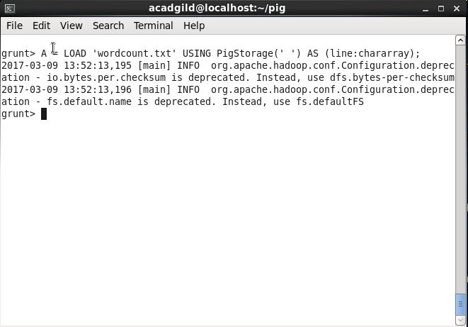

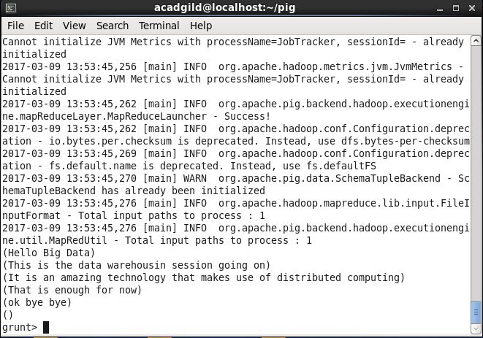

**Convert the sentence into words:**

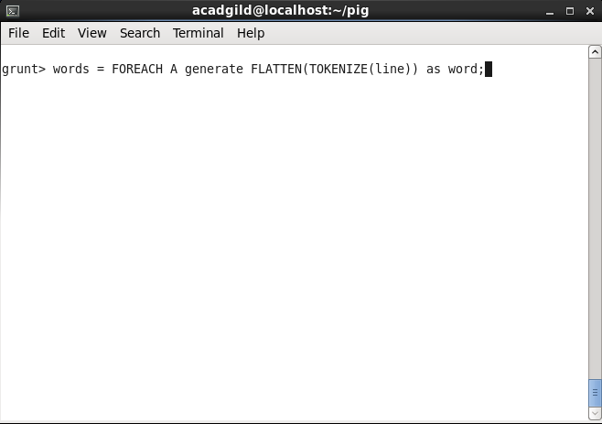

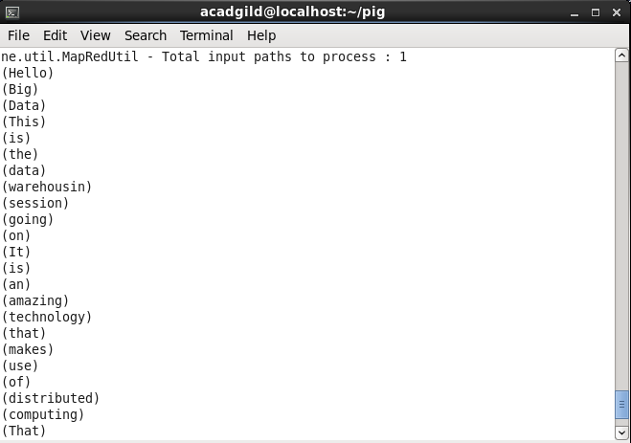

**Apply group by to group same words:**

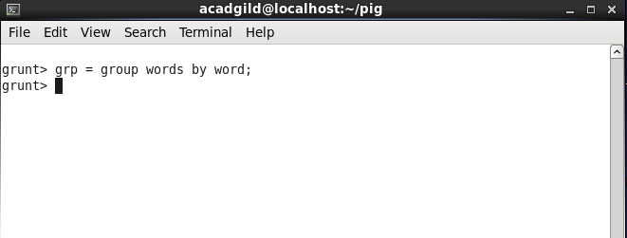

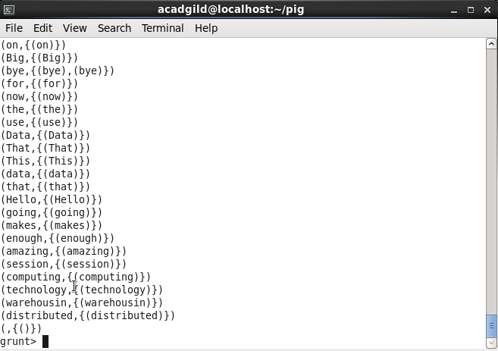

**Generate word count:**

Group by function groups the words that are repeated.

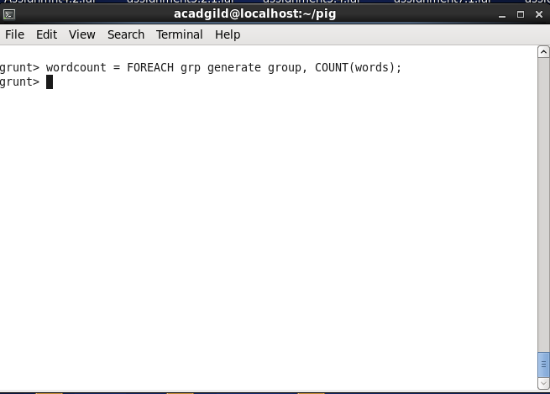

**Output:**

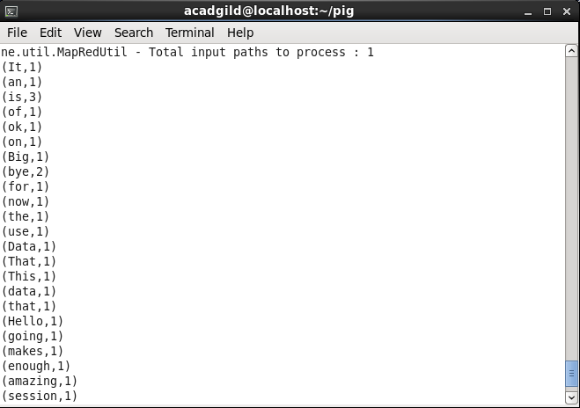

The output of the command gives the count of each word individually.